Ageing, Immigration and Health in Giambellino
Invecchiamento, immigrazione e salute nel quartiere Giambellino
Maristella Bergaglio¹, Luca Vailati²
¹ Dipartimento di Geografia e Scienze Umane dell’Ambiente, Università degli Studi di Milano
² Dipartimento di Geografia e Scienze Umane dell’Ambiente, Università degli Studi di Milano
e-mail: maristella.bergaglio@unimi.it
Keywords: immigration, health, ageing, population, Milan

The Giambellino is a quarter whose name is closely related to the history of the old industrial suburbs of Milan.Situated in the South-West part of Milan, Giambellino assumes today all the problems associated with the reconstruction of a contemporary city, and more specifically its suburbs and popular quarters, under the pressure of global forces. This phenomenon shows through a strong revaluation of all central and semi-central areas, but also creates zones that are not necessarily periphery, where critical elements are concentrated from a social, building and urbanistic point of view. The Giambellino is a good example of all this. In fact, inside a relatively tight zone, there are situations in clear contrast: nuclei of very degraded buildings, immediately adjacent to quarters inhabited by a population with an elevated or even very high social status. Even though the Giambellino is an area with a noticeable presence of economical-purposed and popular building, quarter Giambellino can be distinguished in a clear way because of the concentration of degradation situations and social marginalisation, particularly in the Aler-Lorenteggio building complex.
We can see from the data that in the Lorenteggio complex, within a total of 3,847 habitants, 37.8% of these are aged 65 and over. This statistic is even more significant compared to the 23.0% share of people over 65 years old in the functional area 108, that includes the Lorenteggio complex, 25.3% in the zone of decentralisation 6, a zone where the quarter is situated, and more generally in Milan itself (23.4%). From this, the concentration of elderly people in Aler-Lorenteggio building complex, is very evident. The percentage of young people under 20 years of age in the Lorenteggio complex is only 13.7%, obviously very low if compared to the 108 area (17.4%), but close to the norm for the zone 6 (14.3%), and similarly for the city of Milan itself (14.8%). A particularly relevant fact is that elderly people living alone, in this quarter, make up 18.4% of the total number of habitants.
When it comes to the presence of foreigners in the examined area, the Lorenteggio complex has 11.02% – and while this does not differ apparently from the average – it does deviate quite a lot from its reference zone, the zone 6 (10.0%), while it has lower values than the ones registered in the 108 area (19.8%), a fact that confirms a large concentration of foreigners residing in the area, although not necessarily in the Aler buildings.
The presence of old and degraded buildings, and the concentration of low-income and highly socially vulnerable population, contributes to a worsening of health conditions of the population. The data regarding hospital admissions in 2004 show that in Giambellino-Lorenteggio, there is an extremely high EB-SHR for Tuberculosis, both for males (307,27) than for females (449,70), when compared to other functional areas of the Zone 6. This finding is typical for quarters with concentrations of popular buildings. When it comes to Tuberculosis, this can be considered as an efficient indicator in the evaluation of economic and social inconvenience of a population, because what is at the base of the progress and spread of this disease are lifestyles, living situations, hygienic conditions and inadequate eating habits.

Figure 1: Standard Hospitalization Rate for Tuberculosis (2004).

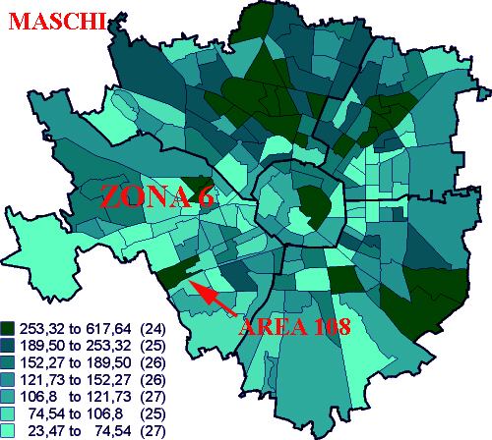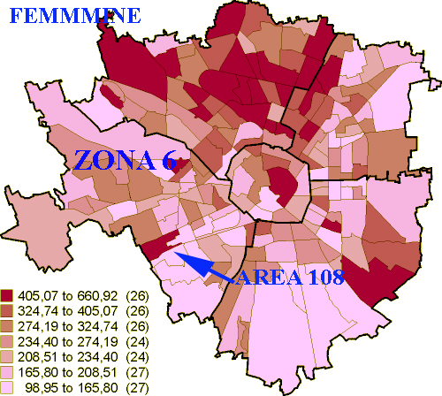

Table 1: Population and foreigners residents in Aler-Lorenteggio (dati 2005), in functional area n°108 and in decentralisation area n°6 (dati 2006)

Quarter Aler-Lorenteggio |  |  |  | Area 108 (a) |  |  | Zone 6 (b)
 | Total | % on (a) | % on (b) | M | F | M |  | F
Population | 3.847 | 39,9 | 2,6 | 4.620 | 5.003 | 69.848 |  | 80.252
P(+65) | 1.455 | 65,6 | 3,8 | 779 | 1.437 | 14.820 |  | 23.255
% (on pop.) | 37,8 | -- | -- | 16,9 | 28,7 | 21,2 |  | 28,9
Foreigners | 424 | 22,2 | 2,8 | 1.013 | 892 | 7.327 |  | 7.688
% (on pop.) | 11,0 | -- | -- | 21,9 | 17,8 | 10,4 |  | 9,6
References
Agustoni A. (2003) I vicini di casa. Mutamento sociale, convivenza interetnica e percezioni urbane nei quartieri popolari di Milano, FrancoAngeli, Milano.
Russo A., Bisanti L. (2005), Ricoveri e mortalità a Milano, Zadig, Milano
Delera A., Ronda E. (2005), Quartieri popolari e città sostenibili, Ed. Lavoro, Roma.
Zajczyk F. (2003), La povertà a Milano. Distribuzione territoriale, servizi sociali e problema abitativo, FrancoAngeli, Milano.

EB-SHR(Standard Hospitalization Rate) is based on 1998 Hospitalization rates in Lombardia, and smoothed by Empirical Bayesiani, cfr. Russo A., Bisanti L. (2005).

